**Bug Report**

1. User is able to do registration even after login into his profile

Steps to Create:

1. Open registration page and register
2. Login with proper credentials in the same page
3. The registration page is still displayed even after login as the page is not getting refreshed

Actual: User is able to register even after login

Expected: User should not be able to register after login to his profile

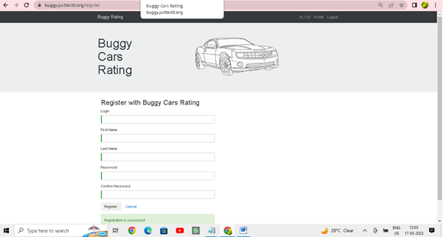

1. Field level defects:
2. System is allowing invalid phone number format and user is able to save it
3. User is able to enter text for Age, Gender fields
4. Last Name, First Name fields are allowing only numbers, only special characters , only spaces also

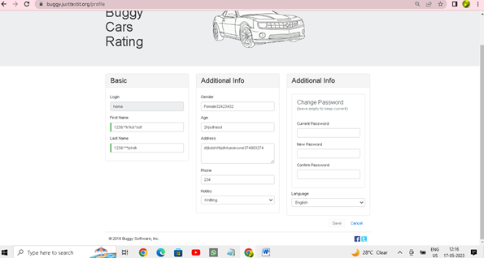

3.

For the Last Name field in Registration page, mandatory validation check displayed as ‘First name is required’ instead of ‘Last Name is required’

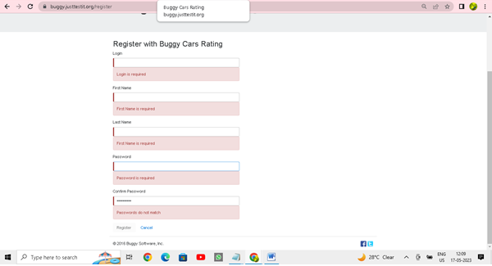

1. User profile details are still displayed even after logout

Steps to recreate:

1. Login to profile
2. Click on profile and able to see basic info
3. Click logout

Actual: user is able to view his info even after logout

Expected: page should get refreshed and user info should not be displayed after logout

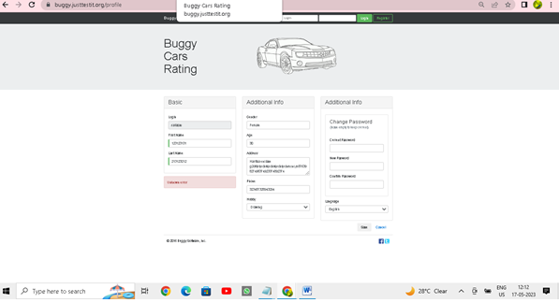

1. Getting Unknown error while selecting knitting as hobby and saving it

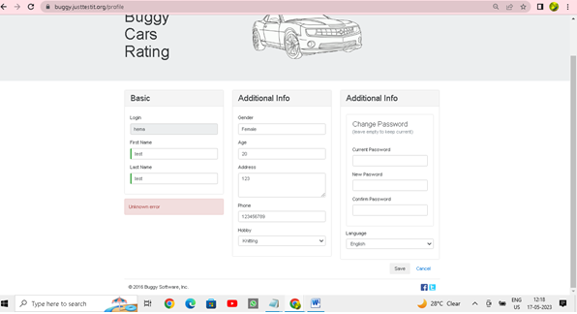

1. Password format validation message is not proper

Steps to Create:

1. Enter 3 digit at password and save
2. It displayed a message min of 6 char needed
3. Enter 6 digit at password and save
4. It displayed a message , password is not long enough

Expected: it should display proper message and should not raise confusion

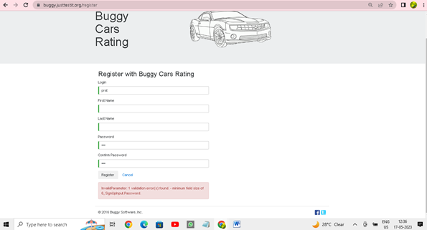

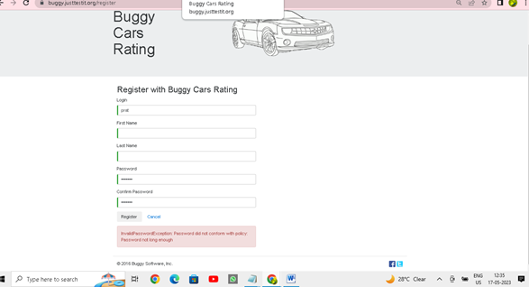

1. Car image is not displayed – Lancia Ypsillon

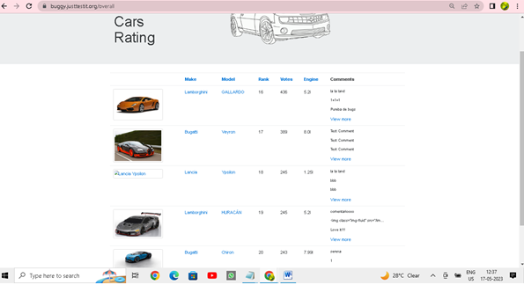

1. Rank ordering filter is displaying incorrect order of ranks

Steps to recreate:

1. Click on list of all cars
2. Click on rank hyperlink
3. Validate the order of the ranks

Actual:

It is displaying random order

Expected: It should display proper ascen or desc order

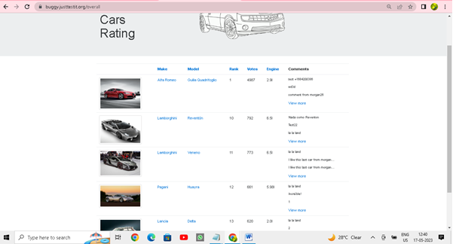

1. Displaying Pages which are not available [ Page 6 out of 5 seems improper]

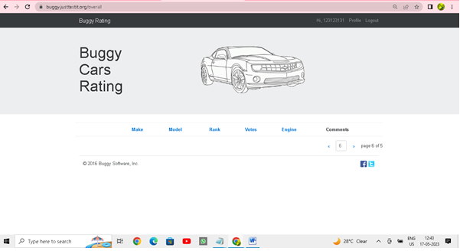

1. Author name is not displayed